**Sample Abstract of CeSMS2024: Information for Authors**

Sota Yoshitakea, Kazuki Sumiyaa, Hiroto Izumib and Kazuo Sakuraia*

aDepartment of Chemistry and Biochemistry, The University of Kiatakyushu, 1-1 Hibikino, Wakamatsuku, Kitakyushu, Fukuoka, 808-0135, JAPAN

b The University of Occupational and Environmental Health, 1-1 Iseigaoka, Yahatanishiku, Kitakyushu, Fukuoka, 807-8556, JAPAN

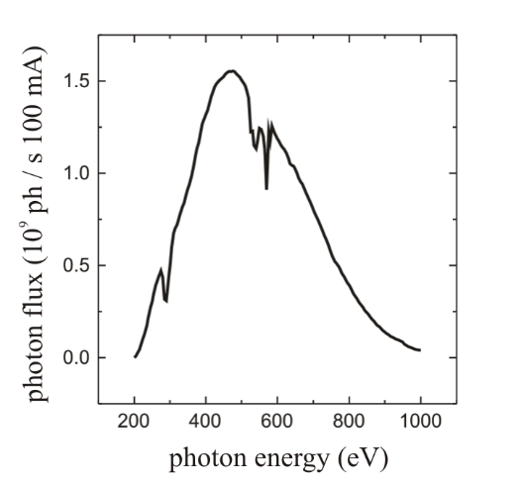

Figure 1: Example of a figure.

Abstracts are limited to one page and must be submitted in PDF format. This template is A4 size, with left and right margins of 22.5 mm and top and bottom margins of 31 mm. The completed printed area, including title, authors, text, figures, tables, and references, should fit within these margins. The font used for the text should be Times New Roman 12pt. The title (in bold) should be centered at the top of the page. The author's name should follow, and the presenter's name should be underlined. Affiliations and full addresses should be in italics, all centered. Use single spacing throughout the document, but include a blank line between the title and author(s) and between the author's affiliation and the text. No page numbers should be added. Figure 1: Example figure. No blank lines are needed between paragraphs. References should be enclosed in square brackets [1]. Figures should be inserted in the appropriate position. The text may wrap around figures and captions. All figures should be cited in the text by number (Figure 1, Figure 2). The use of figure captions is encouraged. Captions should be sufficient to describe the figure without the need to reference the text. Figure captions should be typed using Times New Roman 10pt font. Figure captions should be typed using Times New Roman 10pt font and should include the presenter's name and e-mail address with a horizontal line separating them at the bottom of the page. Text should be centered. The conference language is English. Please double-check margins before uploading.

**References**

[1] A.B. Sample *et al.*, *J. Appl. Cryst.* **55**, 340–352 (2022).

_____________________________________________________________________________

Submitting Author: cesms2024@gmail.com